ASSIGNMENT 3

***QUESTION 1***

**CODE**

#include<stdio.h>

#define size 10

void sub_matrix_2(int sub_matrix[][size],int n,int max[][size],char id[10]);

void sub_matrix_4(int sub_matrix[][size],int n,int max[][size],char id[10]);

void sub_matrix_8(int sub_matrix[][size],int n,int max[][size],char id[10]);

void fill_data(int matrix[][size],int n,char id[10]);

int main(){

printf("23k-0800_Muhammad_Mufeez\n\n\n");

int i,j,k,l;

int max[size][size];

int max_local[size][size];

printf("\nEnter id in form of ***-****: ");

char id[10];

fflush(stdin);

gets(id);

//for 2x2 matrix

sub_matrix_2(max_local,2,max,id);

//for 4x4 matrix

sub_matrix_4(max_local,4,max,id);

//for 8x8 matrix

sub_matrix_8(max_local,8,max,id);

return 0;

}

void fill_data(int matrix[][size],int n,char id[10]){

int arr[4],i,j,k;

for(i=4 ,j=0;i<8,j<4;i++,j++){

arr[j]= id[i] -'0';

}

printf("\n\n");

for(i=0,k=0;i<n;i++){

for(j=0;j<n;j++,k++){

if(k==4)

k=0;

matrix[i][j]=arr[k];

}

}

for(i=0;i<n;i++){

for(j=0;j<n;j++){

printf("%d ",matrix[i][j]);

}

printf("\n");

}

}

void sub_matrix_2(int sub_matrix[][size],int n,int max[][size],char id[10]){

int sm_size = n/2;

int x=0,y=0,i,j,max_val=0,k,l;

fill_data(max,n,id);

for(i=0, x=0;i<=sm_size+2;i+=2,x++){

for(j=0,y=0;j<=sm_size+2;j+=2,y++){

max_val=0;

for(k=i;k<i+2;k++){

for(l=j;l<j+2;l++){

if(max[k][l]>max_val){

max_val= max[k][l];

}

}

}

sub_matrix[x][y] = max_val;

}

}

printf("\n\n\tFor 2x2: \n");

for(i=0;i<sm_size;i++){

for(j=0;j<sm_size;j++){

printf("%d ",sub_matrix[i][j]);}

printf("\n");

}

}

void sub_matrix_4(int sub_matrix[][size],int n,int max[][size],char id[10]){

int sm_size = n/2;

int x=0,y=0,i,j,max_val=0,k,l;

fill_data(max,n,id);

for(i=0, x=0;i<=sm_size+2;i+=2,x++){

for(j=0,y=0;j<=sm_size+2;j+=2,y++){

max_val=0;

for(k=i;k<i+2;k++){

for(l=j;l<j+2;l++){

if(max[k][l]>max_val){

max_val= max[k][l];

}

}

}

sub_matrix[x][y] = max_val;

}

}

printf("\n\n\tFor 4x4: \n");

for(i=0;i<sm_size;i++){

for(j=0;j<sm_size;j++){

printf("%d ",sub_matrix[i][j]);}

printf("\n");

}

}

void sub_matrix_8(int sub_matrix[][size],int n,int max[][size],char id[10]){

int sm_size = n/2;

int x=0,y=0,i,j,max_val=0,k,l;

fill_data(max,n,id);

for(i=0, x=0;i<=sm_size+2;i+=2,x++){

for(j=0,y=0;j<=sm_size+2;j+=2,y++){

max_val=0;

for(k=i;k<i+2;k++){

for(l=j;l<j+2;l++){

if(max[k][l]>max_val){

max_val= max[k][l];

}

}

}

sub_matrix[x][y] = max_val;

}

}

printf("\n\n\tFor 8x8: \n");

for(i=0;i<sm_size;i++){

for(j=0;j<sm_size;j++){

printf("%d ",sub_matrix[i][j]);}

printf("\n");

}

}

**OUTPUT**

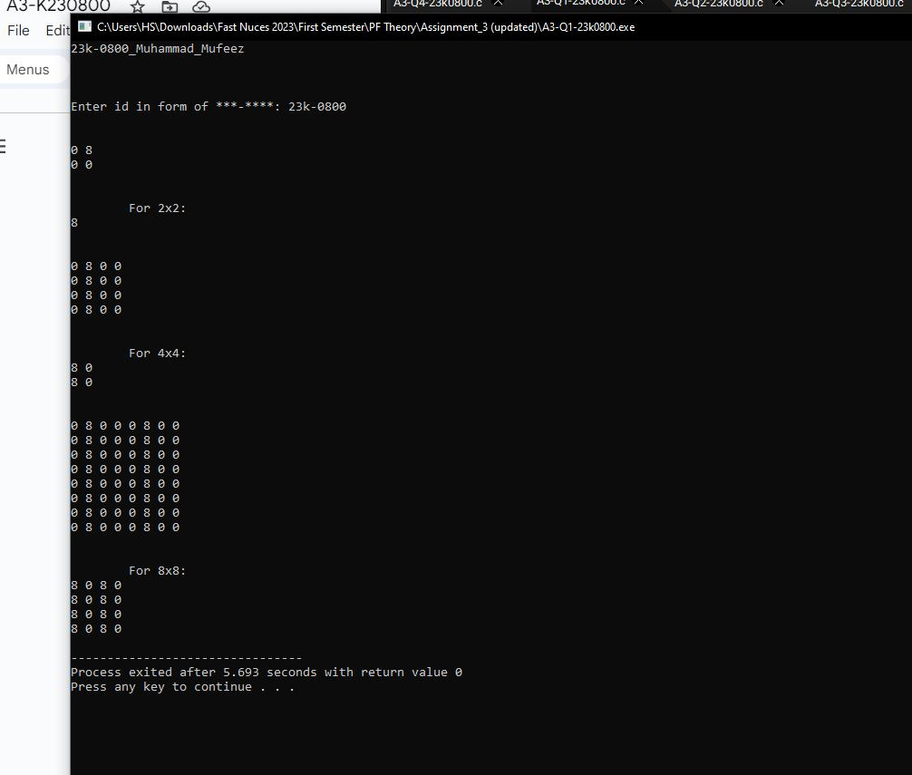

***QUESTION 2***

**CODE**

#include<stdio.h>

#include<string.h>

#include<stdlib.h>

#include<time.h>

typedef struct {

char name[50];

char role[10];

int communication;

int teamwork;

int creativity;

} employee;

typedef struct {

employee emp[5];

} dep;

int main(){

printf("23k-0800_Muhammad_Mufeez\n\n\n");

dep arr[4];

char names[20][50]={"Ahmed","Ali","uzair","mufeez","muzammil","someone","junaid","hanif","aliahmed","aqib","harron","alian","huzaifa","hamza","mazil","adil","basit","maaz","khizr","umair"};

char o_roles[5][30]={"Director","Executive","Manager","Employee","Trainee"};

char dept[4][20] = {"HR","Finance","Marketing","Logistic"};

char roles[5][30];

int n,i=0,k,pos=0,j,index=0,max=0,total,dep_ind;

while(i<4){

j=0;

for(k=0;k<5;k++){

strcpy(roles[k],o_roles[k]);

}

while(j<5){

srand(n+time(NULL));

n++;

index =rand()%20;

pos = rand()%5;

if((strcmp(names[index],"o"))!=0 && strcmp(roles[pos],"o")!=0){

strcpy(arr[i].emp[j].name,names[index]);

strcpy(arr[i].emp[j].role,roles[pos]);

strcpy(names[index],"o");

strcpy(roles[pos],"o");

index++;

arr[i].emp[j].communication=1+rand()%100;

arr[i].emp[j].creativity=1+rand()%100;

arr[i].emp[j].teamwork=1+rand()%100;

j++;

}

}

i++;

}

for(i=0;i<4;i++){

total =0;

for(j=0;j<5;j++){

total = total + arr[i].emp[j].communication + arr[i].emp[j].creativity + arr[i].emp[j].teamwork;

}

if(total > max){

max = total;

dep_ind = i;

}

printf("\nScore of %s department: %d",dept[i],total);

}

printf("\n\nBest Department is %s with score: %d\nFurther details are given:\n\n",dept[dep_ind],max);

for(j=0;j<5;j++){

printf("%s\t\t%s\t\t%d\t\t%d\t\t%d\n",arr[dep_ind].emp[j].name,arr[dep_ind].emp[j].role,arr[dep_ind].emp[j].communication,arr[dep_ind].emp[j].creativity,arr[dep_ind].emp[j].teamwork);

}

//not required but additional, to show the whole data

// for(i=0;i<4;i++){

// printf("\n\nFor department %d\n",i+1);

// for(j=0;j<5;j++){

// printf("%s\t\t%s\t\t%d\t\t%d\t\t%d\n",arr[i].emp[j].name,arr[i].emp[j].role,arr[i].emp[j].communication,arr[i].emp[j].creativity,arr[i].emp[j].teamwork);

// }

// }

return 0;

}

**OUTPUT**

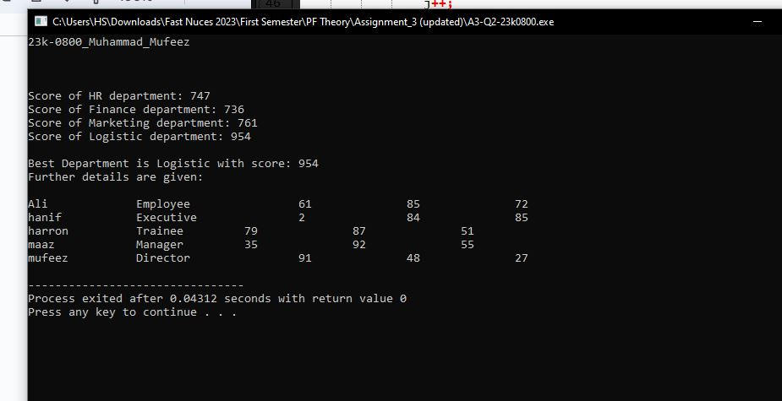

***QUESTION 3***

**CODE**

#include<stdio.h>

#include<string.h>

#include<stdlib.h>

typedef struct personal{

int id;

char name[30];

} pe;

typedef struct department{

int id;

int salary;

} de;

typedef struct combine{

int id;

char name[30];

int salary;

} cm;

void input(int n){

FILE *personal = fopen("23k_0800_personal.txt","w+");

FILE *department = fopen("23k_0800_department.txt","w+");

int id,salary,i;

char name[30];

if(department==NULL || personal==NULL){

printf("One or both files didn't open");

exit(1);

}

printf("\n\nEnter for personal file: ");

for(i=0;i<n;i++){

printf("\nfor user %d:\n",i+1);

printf("\n\tEnter Id: ");

fflush(stdin);

scanf("%d",&id);

printf("\n\tEnter Name: ");

fflush(stdin);

gets(name);

fprintf(personal,"%d %s\n",id,name);

}

printf("\n\nEnter for department file: ");

for(i=0;i<n;i++){

printf("\nfor user %d:\n",i+1);

printf("\n\tEnter Id: ");

scanf("%d",&id);

printf("\n\tEnter Salary: ");

scanf("%d",&salary);

fprintf(department,"%d %d\n",id,salary);

}

rewind(personal);

rewind(department);

sort(n,personal,department);

}

void sort(int n, FILE *personal,FILE *department){

pe tmp_pe[n],per_tmp;

de tmp_de[n],dep_tmp;

int i,j;

for(i=0;i<n;i++){

fscanf(personal,"%d",&tmp_pe[i].id);

fgets(tmp_pe[i].name,50,personal);

fscanf(department,"%d",&tmp_de[i].id);

fscanf(department,"%d",&tmp_de[i].salary);

}

for(j=0;j<n-1;j++){

for(i=0;i<n-1;i++){

if(tmp_pe[i].id>tmp_pe[i+1].id){

per_tmp = tmp_pe[i];

tmp_pe[i]=tmp_pe[i+1];

tmp_pe[i+1] = per_tmp;

}

if(tmp_de[i].id>tmp_de[i+1].id){

dep_tmp = tmp_de[i];

tmp_de[i]=tmp_de[i+1];

tmp_de[i+1] = dep_tmp;

}

}

}

rewind(personal);

rewind(department);

for(i=0;i<n;i++){

fprintf(personal,"%d %s",tmp_pe[i].id,tmp_pe[i].name);

fprintf(department,"%d %d\n",tmp_de[i].id,tmp_de[i].salary);

}

fclose(personal);

fclose(department);

}

void combine(int n){

int i,j;

struct combine arr[n];

FILE *personal = fopen("23k_0800_personal.txt","r");

FILE *department = fopen("23k_0800_department.txt","r");

FILE *combine = fopen("23k_0800_combine.txt","w");

if(department==NULL || personal==NULL || combine ==NULL){

printf("One or both files didn't open");

exit(1);

}

pe tmp_pe[n];

de tmp_de[n];

for(i=0;i<n;i++){

fscanf(personal,"%d",&tmp_pe[i].id);

fgets(tmp_pe[i].name,50,personal);

fscanf(department,"%d",&tmp_de[i].id);

fscanf(department,"%d",&tmp_de[i].salary);

arr[i].id = tmp_pe[i].id;

strcpy(arr[i].name,tmp_pe[i].name);

arr[i].salary = tmp_de[i].salary;

}

for(i=0;i<n;i++){

arr[i].name[strcspn(arr[i].name, "\n")] = '\0';

fprintf(combine,"%d %s %d\n",arr[i].id,arr[i].name,arr[i].salary);

}

printf("\n\ncombined file is given below: \n");

for(i=0;i<n;i++){

printf("%d %s %d\n",arr[i].id,arr[i].name,arr[i].salary);

}

fclose(personal);

fclose(department);

fclose(combine);

}

int main(){

printf("23k-0800_Muhammad_Mufeez\n\n\n");

int n,id;

printf("Enter number of employees: ");

scanf("%d",&n);

input(n);

combine(n);

return 0;

}

**OUTPUT**

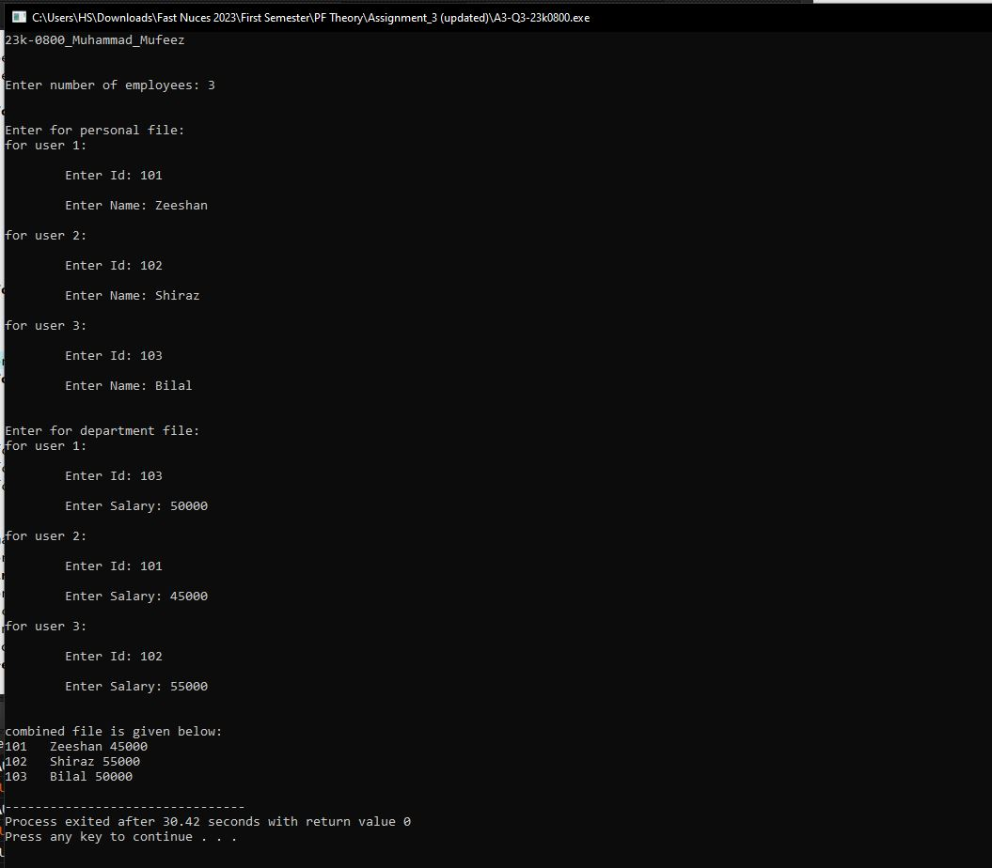

***QUESTION 4***

**CODE**

#include<stdio.h>

#include<string.h>

#include<stdlib.h>

#include<time.h>

typedef struct {

int w_id;

char f_name[50];

char l_name[10];

int salary;

char date[25];

char dept[15];

} work;

typedef struct {

int w_id;

char date[25];

int bonus;

} bonus;

typedef struct {

int w_id;

char dept[15];

char date[25];

} title;

int main(){

printf("23k-0800_Muhammad_Mufeez\n\n\n");

int i,hr_high=0,admin_high=0,acc_high=0,hr_ind,admin_ind,acc_ind,total_hr=0,total_admin=0,total_account=0;

work work_data[8];

bonus bonus_data[5];

title title_data[8];

FILE *fptr = fopen("23k_0800_q4.txt","r");

if(fptr==NULL){

printf("File didn't open");

exit(1);

}

for(i=0;i<8;i++){

fscanf(fptr,"%d %s %s %d %s %s",&work_data[i].w_id,work_data[i].f_name,work_data[i].l_name,&work_data[i].salary,work_data[i].date,work_data[i].dept);

}

for(i=0;i<5;i++){

fscanf(fptr,"%d %s %d",&bonus_data[i].w_id,bonus_data[i].date,&bonus_data[i].bonus);

}

for(i=0;i<8;i++){

fscanf(fptr,"%d %s %s",&title_data[i].w_id,title_data[i].dept,title_data[i].date);

}

fclose(fptr);

for(i=0;i<8;i++){

if(strcmp(work_data[i].dept,"HR")==0){

if(work_data[i].salary>hr_high){

hr_high = work_data[i].salary;

hr_ind = i;

total_hr += work_data[i].salary;

}else

total_hr += work_data[i].salary;

}

if(strcmp(work_data[i].dept,"Admin")==0){

if(work_data[i].salary>admin_high){

admin_high = work_data[i].salary;

admin_ind = i;

total_admin += work_data[i].salary;

}else

total_admin += work_data[i].salary;

}

if(strcmp(work_data[i].dept,"Account")==0){

if(work_data[i].salary>acc_high){

acc_high = work_data[i].salary;

acc_ind = i;

total_account += work_data[i].salary;

}else

total_account += work_data[i].salary;

}

}

printf("\n\n\tREQUIRED OUTPUTS ARE GIVEN: ");

printf("\n\t%d\t%s\t%s\t%d\t%s\t%s\n",work_data[hr_ind].w_id,work_data[hr_ind].f_name,work_data[hr_ind].l_name,hr_high,work_data[hr_ind].date,work_data[hr_ind].dept);

printf("\t%d\t%s\t%s\t%d\t%s\t%s\n",work_data[admin_ind].w_id,work_data[admin_ind].f_name,work_data[admin_ind].l_name,admin_high,work_data[admin_ind].date,work_data[admin_ind].dept);

printf("\t%d\t%s\t%s\t%d\t%s\t%s\n",work_data[acc_ind].w_id,work_data[acc_ind].f_name,work_data[acc_ind].l_name,acc_high,work_data[acc_ind].date,work_data[acc_ind].dept);

printf("\n\tHR - %d",total_hr);

printf("\n\tAdmin - %d",total_admin);

printf("\n\tAccount - %d",total_account);

// to see the fetched data from file, kindly uncomment the code below

// printf("\n\nExtraneous to show the data of files: \n\n");

// for(i=0;i<8;i++){

// printf("%d\t%s\t%s\t%d\t%s\t%s\n",work_data[i].w_id,work_data[i].f_name,work_data[i].l_name,work_data[i].salary,work_data[i].date,work_data[i].dept);

// }

// printf("\n\n");

// for(i=0;i<5;i++){

// printf("%d\t%s\t%d\n",bonus_data[i].w_id,bonus_data[i].date,bonus_data[i].bonus);

// }

// printf("\n\n");

// for(i=0;i<8;i++){

// printf("%d\t%s\t%s\n",title_data[i].w_id,title_data[i].dept,title_data[i].date);

// }

return 0;

}

**OUTPUT**

